**MINOR PROJECT - 2**



School of Computer Science

UNIVERSITY OF PETROLEUM AND ENERGY STUDIES

DEHRADUN-248007, UTTARAKHAND

**END -TERM**

**PROJECT REPORT**

For

**Edu Scan: Bridging Gaps in Villages**

Submitted By:

|  |  |  |
| --- | --- | --- |
| **Specialization** | **SAP ID** | **Name** |
| DevOps (Hons) | 500091334 | Anushk Sanghvi |
| DevOps (NH) | 500095268 | Chitranshu Sharma |
| DevOps (NH) | 500095191 | Devesh Singh |
| DevOps (NH) | 500094899 | Raghav Mittal |

|  |  |
| --- | --- |
| Dr. Arjun Arora | Dr. Hitesh Kumar Sharma |
| **Project Mentor** | **Cluster Head** |
| **Project Report** |  |

**Project Title**

Edu Scan: Bridging Gaps in Villages

## Abstract

This project focuses on the real-life problems of rural villages student through a website which is “Edu Scan” an initiative aimed at bridging educational disparities in rural villages. In many parts of the world, access to qualify education remains a challenge, particularly in remote and underprivileged communities. This project is designed to address these gaps and empower village residents through education. Edu Scan facilitates personalized learning experiences that cater to the unique needs of each village. This project aims to create a supportive environment for both students and adults, fostering a culture of continuous learning. The ultimate goal is to create a sustainable model for educational empowerment in rural villages, ultimately bridging the gaps that hinder socio-economic progress.

# Acknowledgements

We extend our heartfelt gratitude to those who have played a pivotal role in the successful completion of our minor project on ‘**Edu Scan- Bridging gaps in Villages’**. This collective effort has been made possible through the unwavering support, guidance, and cooperation of numerous individuals and entities.

First and foremost, we express our sincere appreciation to our mentor, **Dr. Arjun Arora**, whose guidance and expertise have been instrumental in shaping the course of our project. His continuous support, valuable insights, and meticulous attention to detail have immensely contributed to the refinement and success of our endeavor. We are truly fortunate to have had him as our guide throughout this journey.

We would also like to thank our class coordinator, **Mr. Sandeep Kumar Sir**, and activity coordinator, **Mr. Sandeep Kumar sir**, for their invaluable assistance in providing information about minor project guidelines, maintaining transparency, and facilitating streamlined communication. Their efforts have played a crucial role in keeping us well-informed and organized throughout the project duration.

Our gratitude extends to our evaluator, **Mr. Amarendra Nath Tripathi**, for the time and effort invested in evaluating our work. The constructive feedback and insightful suggestions provided have been crucial in identifying areas for improvement and guiding us towards future extensions of the project.

To our friends and family, we express our deepest appreciation for their unwavering support and understanding during the demanding phases of this project. Their encouragement has been a constant source of motivation for the entire team.

We extend our thanks to the UPES for providing us with this valuable opportunity to explore and implement our ideas in a real-world scenario. This experience has been instrumental in our academic and professional growth.

Last but not least, we acknowledge the exceptional teamwork and dedication of our fellow teammates. Each member has played a vital role in the successful execution of this project, and we commend their collaborative spirit and hard work.

Together, as a team, we have achieved a significant milestone, and we look forward to applying the lessons learned in future endeavors. Thank you all for being an integral part of this journey.

Sincerely,

Chitranshu Sharma, Devesh Singh, Raghav Mittal, Anushk Sanghvi

**Table of Contents**

|  |  |  |
| --- | --- | --- |
| **Topic** | | **Page No.** |
| **Table of Content** | |  |
| 1 | Introduction | 5 |
| 2 | Literature Review | 5 |
| 3 | Problem Statement | 6 |
| 4 | Objective | 6 |
| 5 | Methodology | 6-7 |
| 6 | Technology Stack | 7 |
| 7 | SWOT Analysis | 7-8 |
| 8 | Data Flow Diagram | 9 |
| 9 | PERT Chart | 9 |
| 10 | Edu-Scan User Interface [Result Analysis] | 10-20 |
| 11 | References | 20 |
| 12 | Ground Survey | 21 |

## 1. Introduction

In the vast landscapes of rural villages, where the rhythm of life often unfolds amidst the serenity of nature, lies a persistent challenge: the gap in educational opportunities. The main motive of our project is to provide a sustainable platform to the rural village students who are not able to understand the things carefully or getting difficulty in catching the things and the challenges facing in rural villages are manifold, ranging from inadequate infrastructure to socio-economic barriers that hinder access to education. However, our agenda is that we can provide a platform through our QR based website which stands as a testament to the belief that every child, regardless of their geographical location or socio-economic background, deserves access to quality education.

We will design a website using the HTML and CSS for the frontend and node.js for the backend and in the website, we mainly focus on the 1 to 5 classes students of rural villages. We have created the different-different sections for the different classes so that every student is able to access them and we can also add some additional information related to the general knowledge, communication skills techniques so that students can also develop these skills side by side. We try to add the content in the form of animated or cartoon form so that when the student should access them, they would enjoy while learning. We can also add some quizzes, questions banks so that student should practice whatever the things they have learned so far.

Lastly, we use some DevOps tools to deploy our whole website we use terraform, ansible and if we want any other tool then we use Kubernetes for deploying and orchestrate our website. Our main agenda is to make education easy for the rural villages student who think that education is a very heavy burden or they don’t understand the things easily, so make easy and make knowledgeable.

**AGENDA – “MAKE EASY AND MAKE KNOWLEDGEABLE”**

## 2.Literature Review

Rural education faces numerous challenges, including limited access to quality infrastructure, shortage of qualified teachers, socio-economic barriers, and lack of technological resources These challenges contribute to disparities in educational outcomes and perpetuate cycles of poverty and inequality in rural communities.

Technology plays a transformative role in addressing educational challenges in rural areas. Digital platforms, online learning tools, and mobile technologies offer opportunities to expand access to educational resources and facilitate personalized learning experiences (Davis & Pearce, 2019). By leveraging technology, educational interventions can reach remote villages and provide students with interactive and engaging learning opportunities.

Several case studies highlight successful educational interventions in rural areas that share similarities with the Edu Scan initiative. The Digital Study Hall project in India demonstrates the effectiveness of video-based learning in improving educational outcomes in remote villages (Abhijit & Rukmini, 2018). Similarly, the Bridge Academy model in Africa emphasizes low-cost, scalable solutions for delivering quality education in underserved communities.

## 3. Problem Statement

1. **Limited Access to Quality Infrastructure**: Rural villages often lack proper school buildings, classrooms, libraries, and other educational facilities.
2. **Shortage of Qualified Teachers:** Rural areas struggle to attract and retain qualified teachers due to lower salaries, limited professional development opportunities, and isolation from urban centers.
3. **Socioeconomic Barriers:** Students from lower-income families face challenges accessing educational resources, including books, uniforms, and transportation.
4. **Limited Curriculum and Extracurricular Activities:** Rural schools may offer a limited range of courses and extracurricular activities due to resource constraints. This limitation can impede students' ability to explore diverse interests and develop essential skills beyond academics.
5. **Geographical Isolation:** Schools located in remote areas face challenges in terms of accessibility, transportation, and connectivity. Geographic isolation also affects teacher recruitment and professional development opportunities.

## 4. Objective

1. Expanding Access to Quality Education.
2. Fostering Community Engagement and Empowerment.
3. Enhancing Educational Outcomes.
4. Deploying our website using DevOps Tools.

## 5.Methodology

* Agile methodology is an iterative approach to software development and project management that emphasizes flexibility, collaboration, and customer feedback.
* The project is broken down into small, manageable chunks called iterations or sprints. Each sprint typically lasts for a few weeks and results in a potentially shippable product increment.
* Agile allows for changes to be incorporated throughout the development process which makes our project more flexible and adaptable.
* Agile promotes continuous improvement through regular reflection and adaptation. At the end of each sprint, the team conducts a retrospective to identify what went well, what could be improved, and any adjustments needed for future sprints. This allows the team to respond to lessons learned and refine their approach over time.

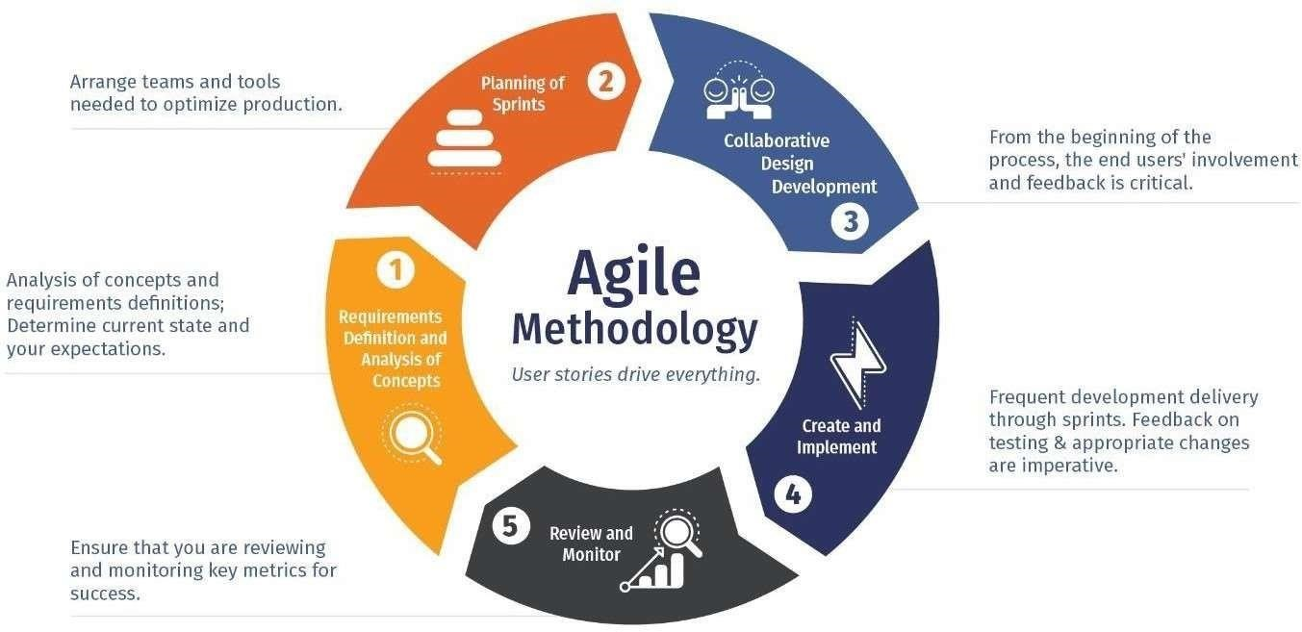

**6. Technology Stack:**

* **Front-End Development:** HTML, CSS, JavaScript
* **Back-End Development:** Node.js for server-side logic
* **Database:** NoSQL Data Base- MongoDB for Data Base storage
* **Version Control:** Git and GitHub for code versioning and collaboration
* **Hosting and Deployment:** Render
* **DevOps Tools:** Git/GitHub
* **Development Environment:** Integrated Development Environments (IDEs) such as Visual Studio Code or PyCharm •
* **Animating the Content:** Adobe Animate, Blender

## 7.SWOT Analysis

**Strengths:**

1. **Innovative Approach:** The project utilizes technology, specifically a QR-based website, to deliver educational content to rural villages, which can effectively bridge the gap in educational opportunities.
2. **Personalized Learning:** By offering content tailored to the unique needs of each village and student, the project can address specific educational challenges effectively. **iii. Community Engagement:** The initiative aims to foster community engagement and empowerment, which can lead to greater support and sustainability of the project. **iv. Agile Methodology:** The adoption of Agile methodology allows for flexibility, collaboration, and continuous improvement throughout the development process.

**Weaknesses:**

1. **Technological Barriers:** Limited access to technology or internet connectivity in rural areas may hinder the effectiveness of the QR-based website.
2. **Resource Constraints:** Rural villages often face resource constraints, including financial limitations and infrastructure challenges, which could impact the implementation and scalability of the project.
3. **Quality Assurance:** Ensuring the quality and accuracy of educational content, especially when delivered through digital platforms, may pose challenges and require ongoing monitoring and evaluation.
4. **Dependency on Volunteers:** The success of community engagement initiatives may rely heavily on the availability and commitment of volunteers, which could be inconsistent.

**Opportunities:**

1. **Partnerships:** Collaborating with local organizations, governments, or NGOs can provide opportunities for resource sharing, funding, and scalability.
2. **Expansion of Services:** The project can expand its services beyond educational content delivery to include additional support, such as vocational training or healthcare initiatives, further enhancing its impact.
3. **Technological Advancements:** Advancements in technology, such as improved internet connectivity or mobile penetration, can create new opportunities to reach more remote villages effectively.
4. **Policy Support:** Advocacy for policies that prioritize education in rural areas can create a supportive environment for the project's objectives and sustainability.

**Threats:**

1. **Economic Instability:** Economic downturns or financial crises can affect funding availability, potentially jeopardizing the project's sustainability.
2. **Cultural Resistance:** Cultural norms or attitudes towards education may pose barriers to community engagement or acceptance of the project.
3. **Political Instability:** Political unrest or changes in government priorities may disrupt project implementation or funding support.
4. **Competition:** Competition from other educational initiatives or programs targeting rural areas may pose challenges in attracting and retaining beneficiaries.

## 8. Data Flow Diagram

**APPROVED**

**LOGIN**

**TO**

**WEBSITE**

**USER DETAILS**

**DATABASE**

**USER**

**CREATE**

**NEW**

**USER**

**USER**

**DETAILS**

**USER DETAILS**

**DATABASE**

**SUBJECT**

**DATABASE**

**LOGIN**

**DETAILS**

**SELECT**

**CLASS**

**SELECT**

**SUBJECT**

**FETCH**

**DATA**

**HOME**

**PAGE**

**USER**

## 9. PERT Chart

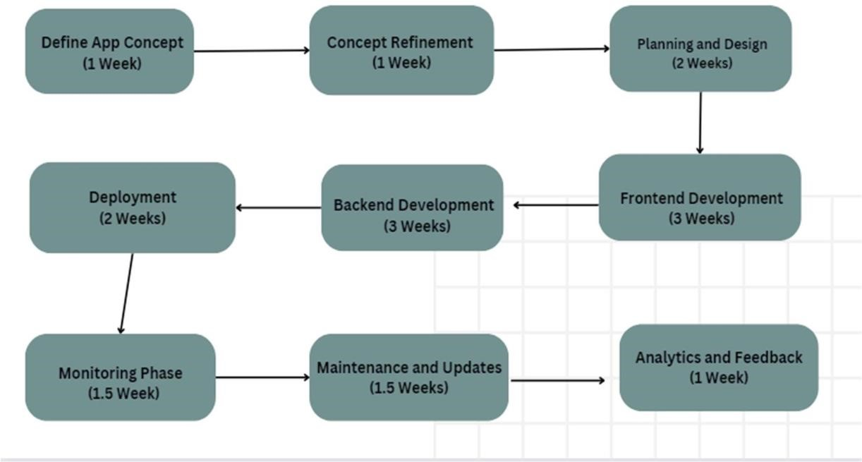

**10. Edu-Scan User Interface / [Result Analysis]**

**Programming Concepts and UI Design: -**

**1) Frontend Development:** Frontend development involves creating the user interface (UI) that users interact with when accessing the Edu-Scan platform. This includes designing and implementing web pages where users can view educational content, sign in or sign up, navigate different sections of the website, and interact with various features.

* Designing the layout and structure of web pages using HTML.
* Styling the UI elements to create an attractive and user-friendly interface using CSS.
* Adding interactivity and dynamic behavior to the UI using JavaScript.

### Sign in Page: -

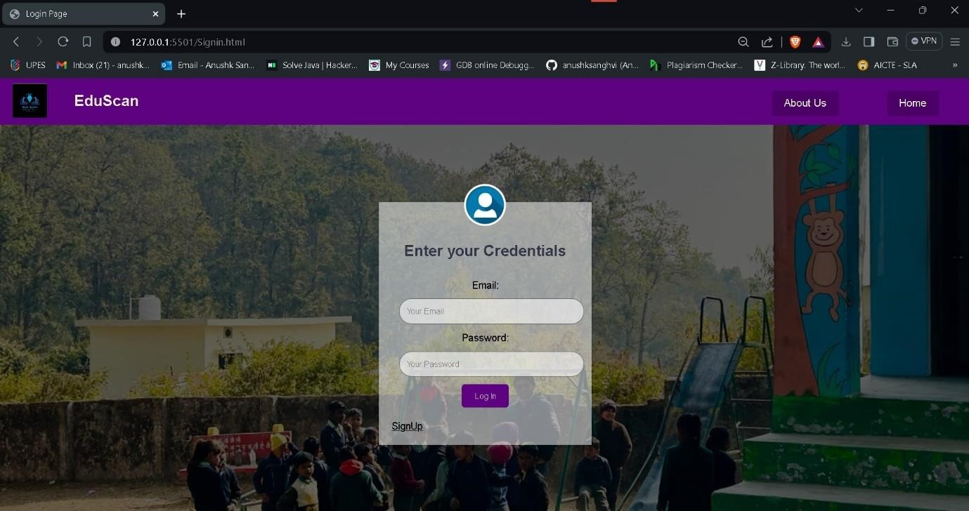

Sign Up page: -

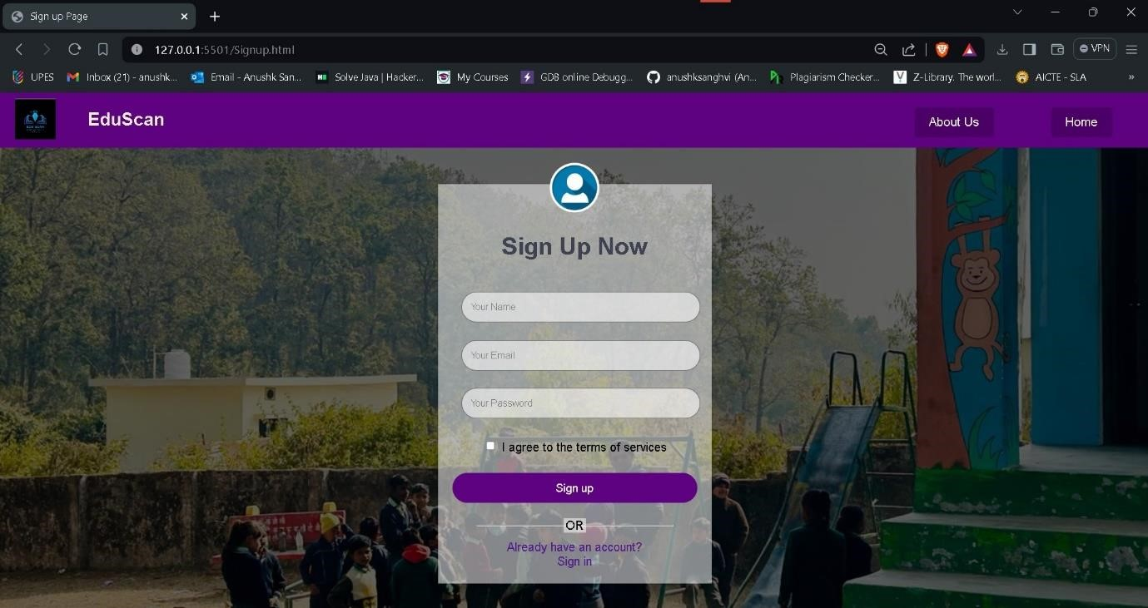

### Landing Page: -

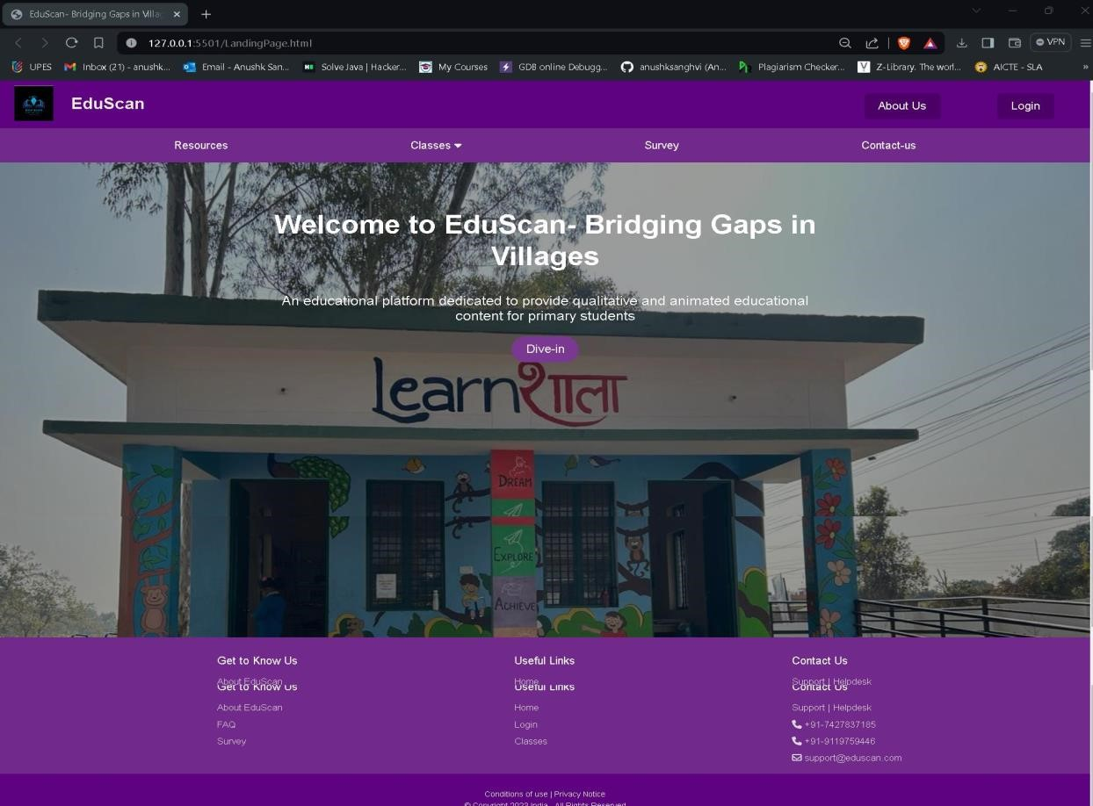

### Home-Page: -

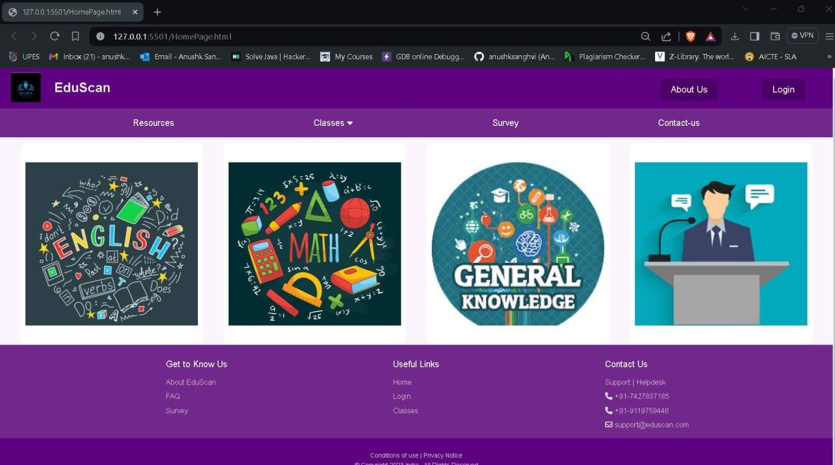

### Class-1 Page:

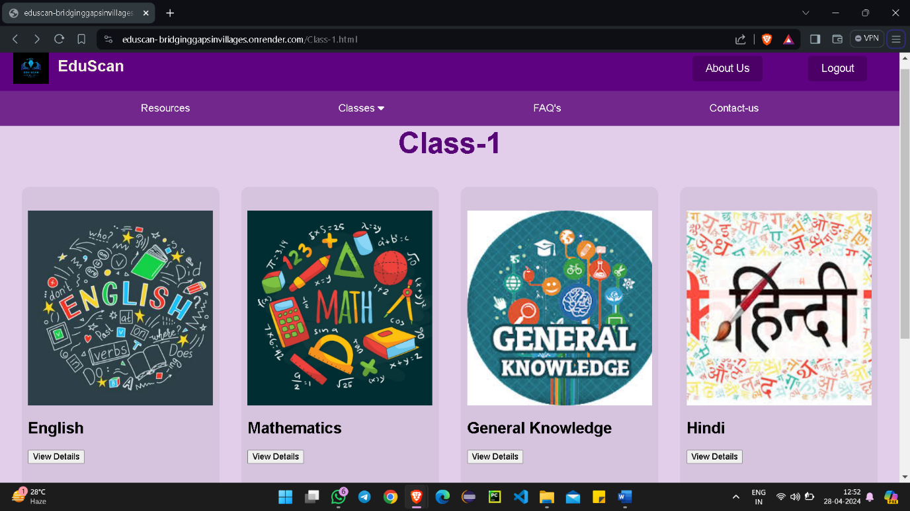

**English Subject Page:**

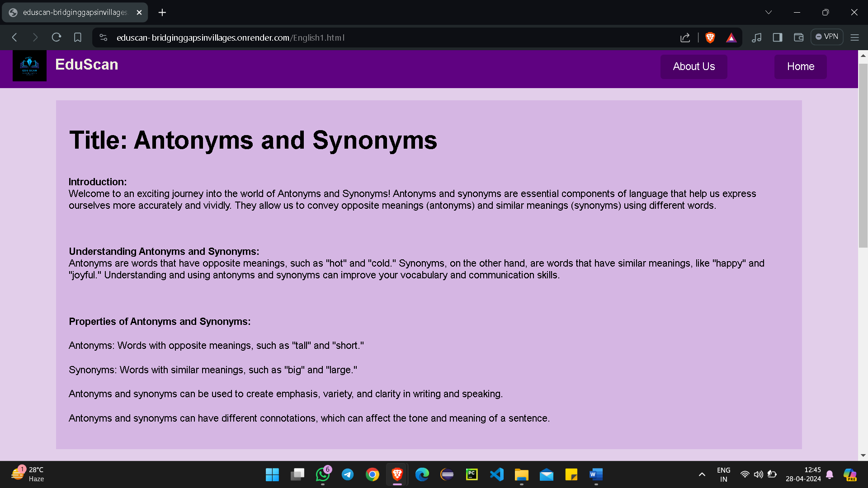

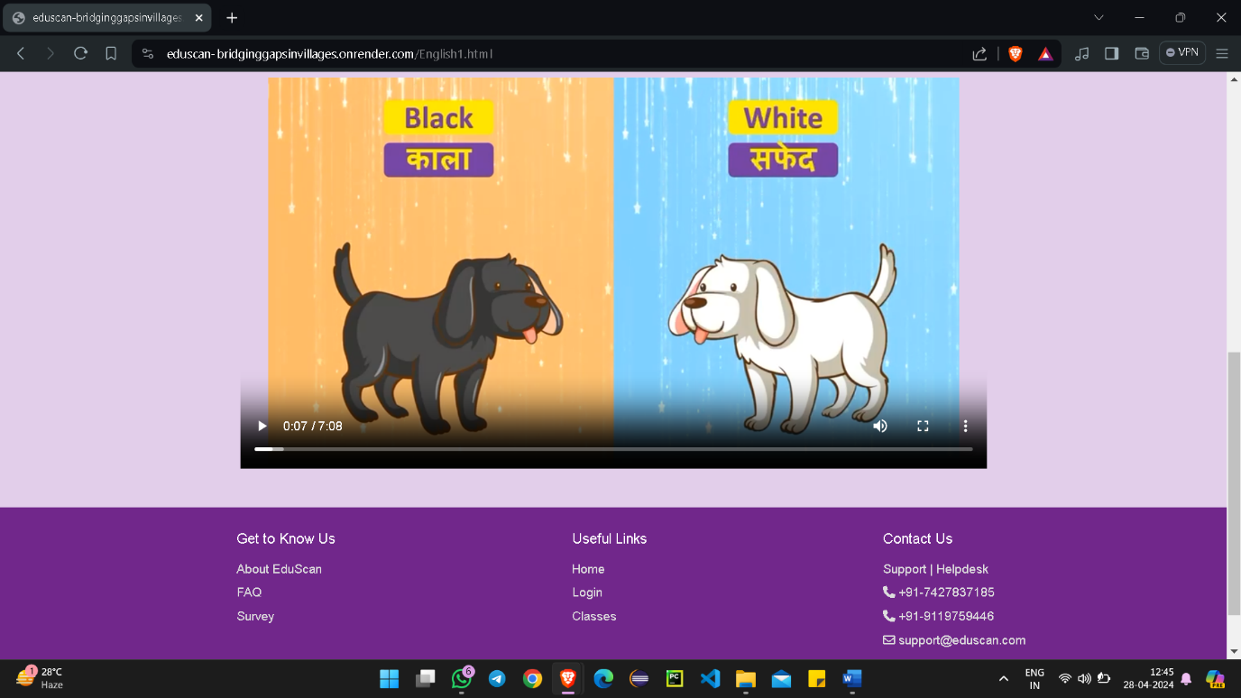

**Hindi Subject Page:**

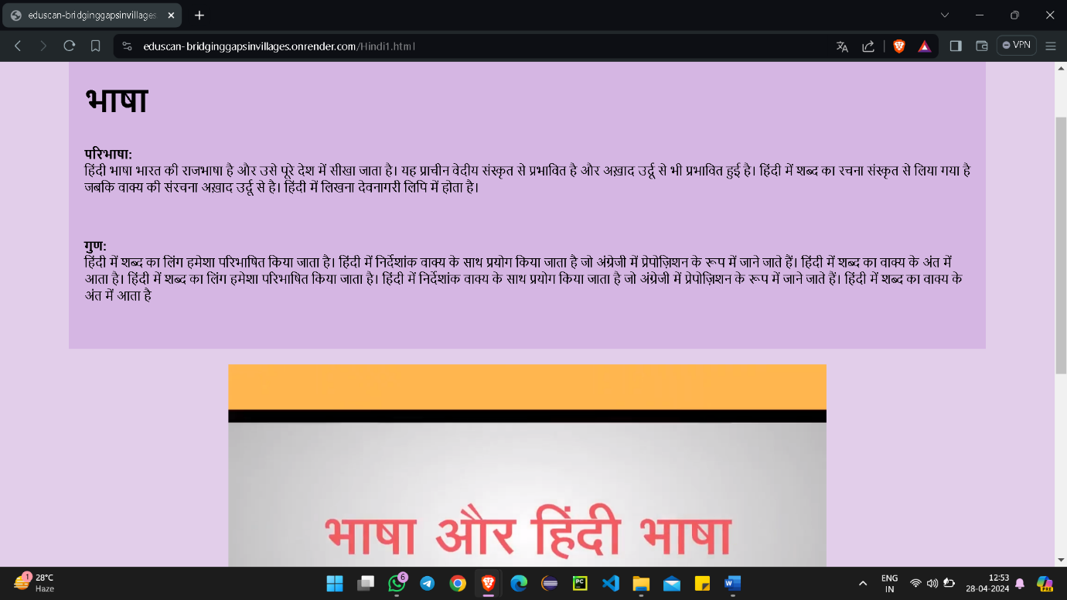

**Maths Subject Page:**

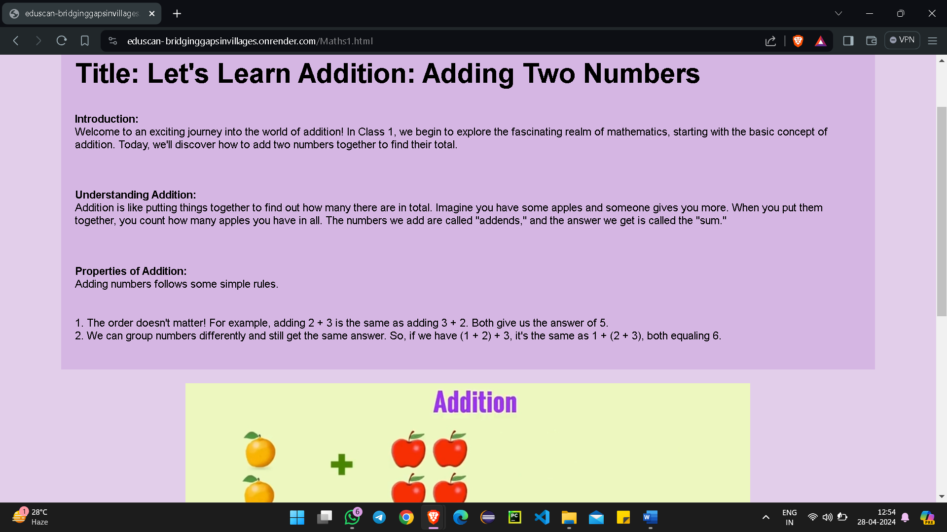

**GK Subject Page:**

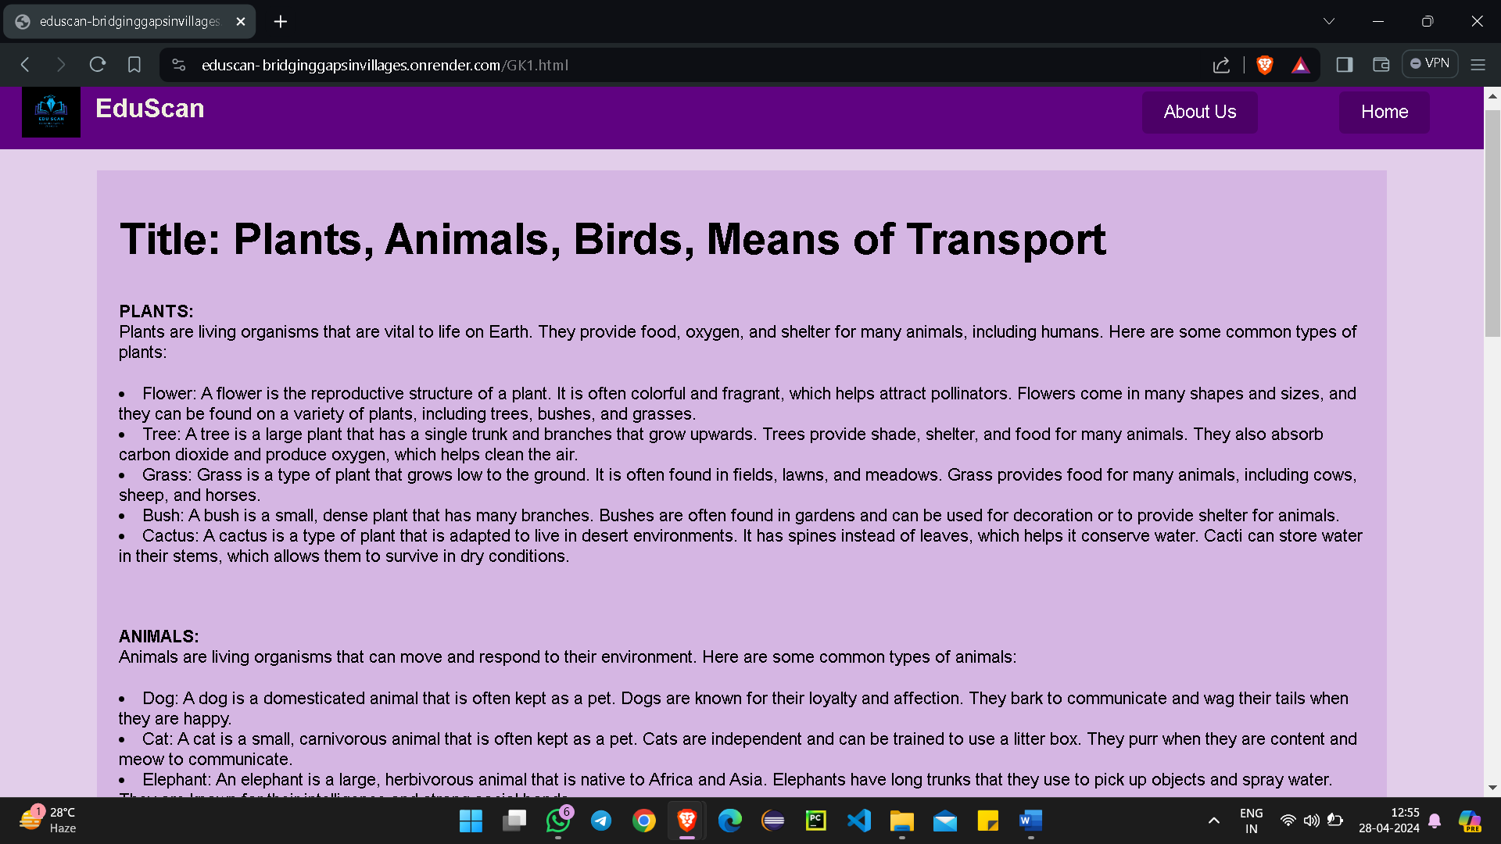

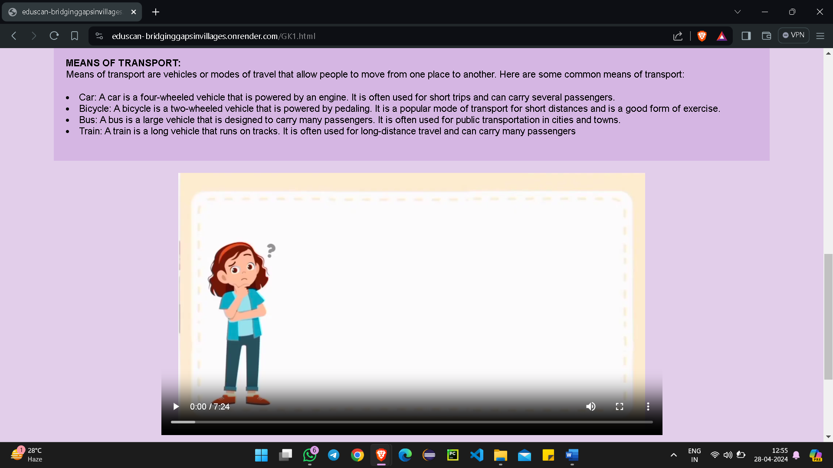

### About-Us Page: -

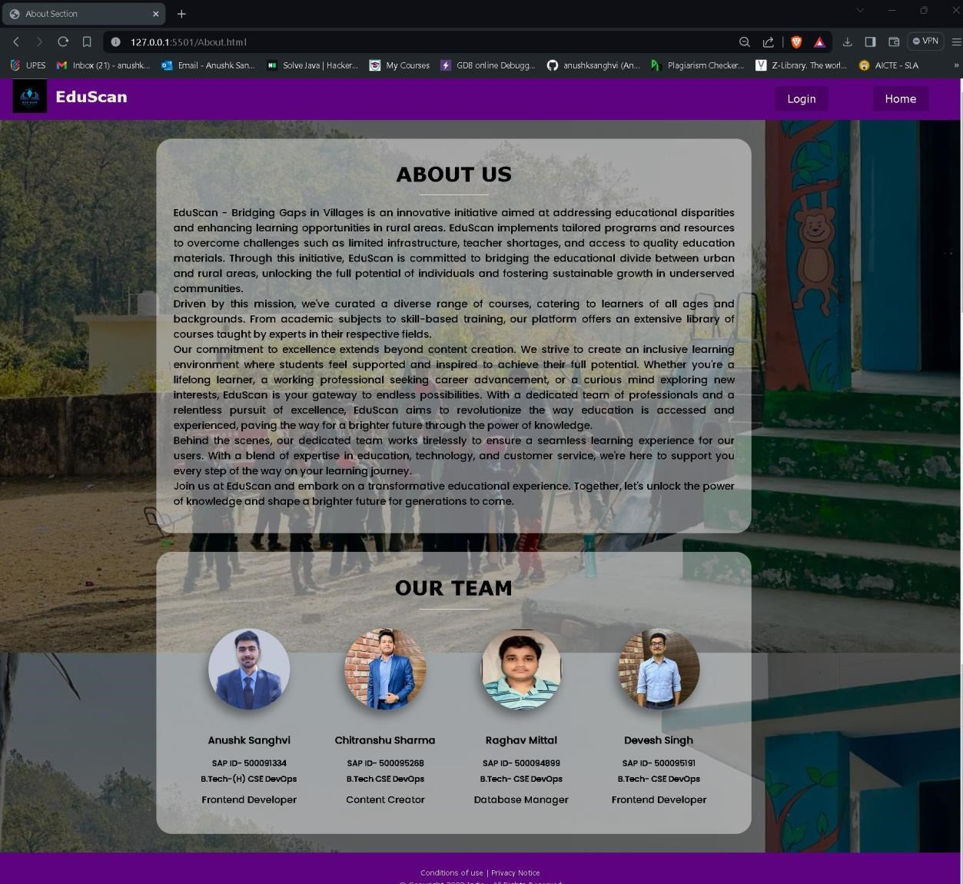

### FAQ Page: -

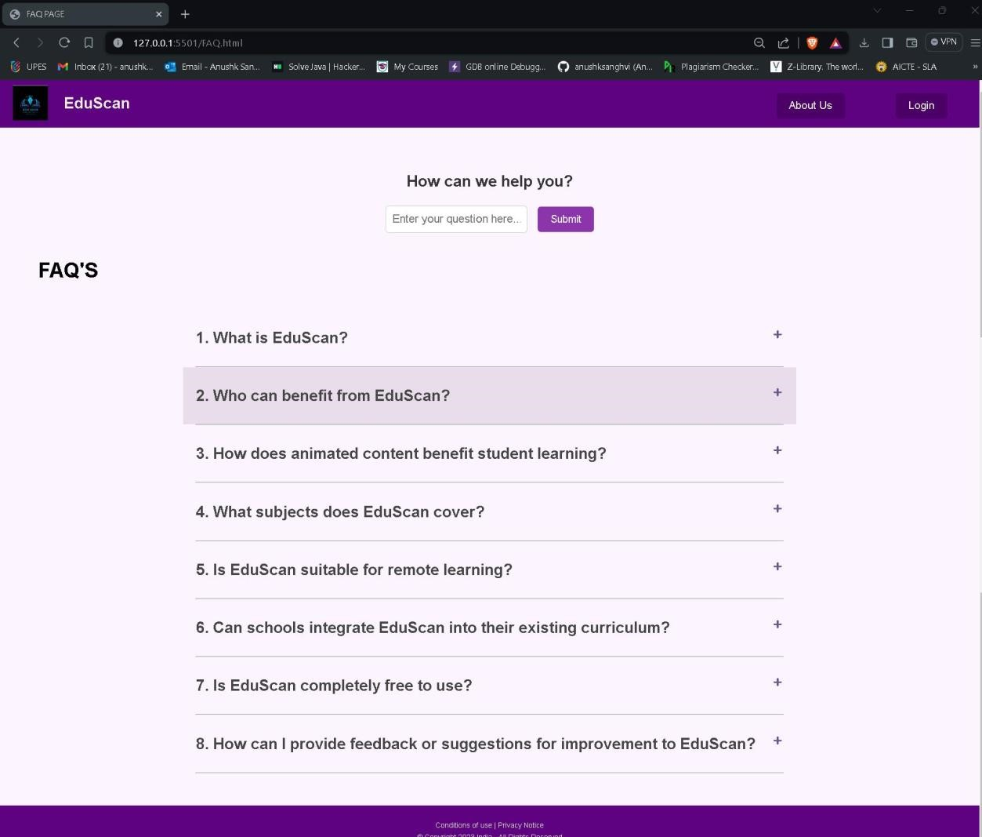

1. **Database Management:** Database management involves storing, retrieving, and managing data related to educational content, user accounts, survey responses, and other information within the Edu-Scan platform.

MongoDB is used for database management.

MongoDB is a popular open-source, NoSQL (Non-relational) document database. It is designed to store data in flexible, JSON-like documents with dynamic schemas, making it easier to work with data whose structure may change over time.

* Create a Cluster: Once logged in to MongoDB Atlas, create a new cluster by selecting your preferred cloud provider, region, and cluster configuration.
* Create a Database: After creating the cluster, navigate to the "Databases" tab and create a new database for your application.
* Set Up Database Users: Create database users with appropriate permissions to access the database.
* Connect to the Cluster: Obtain the connection string for your MongoDB Atlas cluster, which includes the hostname, port number, database name, and authentication credentials.
* Integrate with Application Backend: In your application backend code (e.g., Node.js, Python, Java), use a MongoDB driver or library to connect to your MongoDB Atlas cluster using the connection string obtained.

Using MongoDB Cloud Database for storing user information like usernames, emails, and passwords for login purposes provides a scalable and secure solution. With MongoDB Atlas, data is stored in a flexible document-based format, allowing easy adaptation to changing application requirements. By leveraging MongoDB's robust security features such as encryption at rest and role-based access control, sensitive user data remains protected. Integration with application backends is seamless, enabling efficient data access and manipulation. Overall, MongoDB Cloud Database offers reliability, scalability, and security for managing user authentication and login credentials in web and mobile applications.

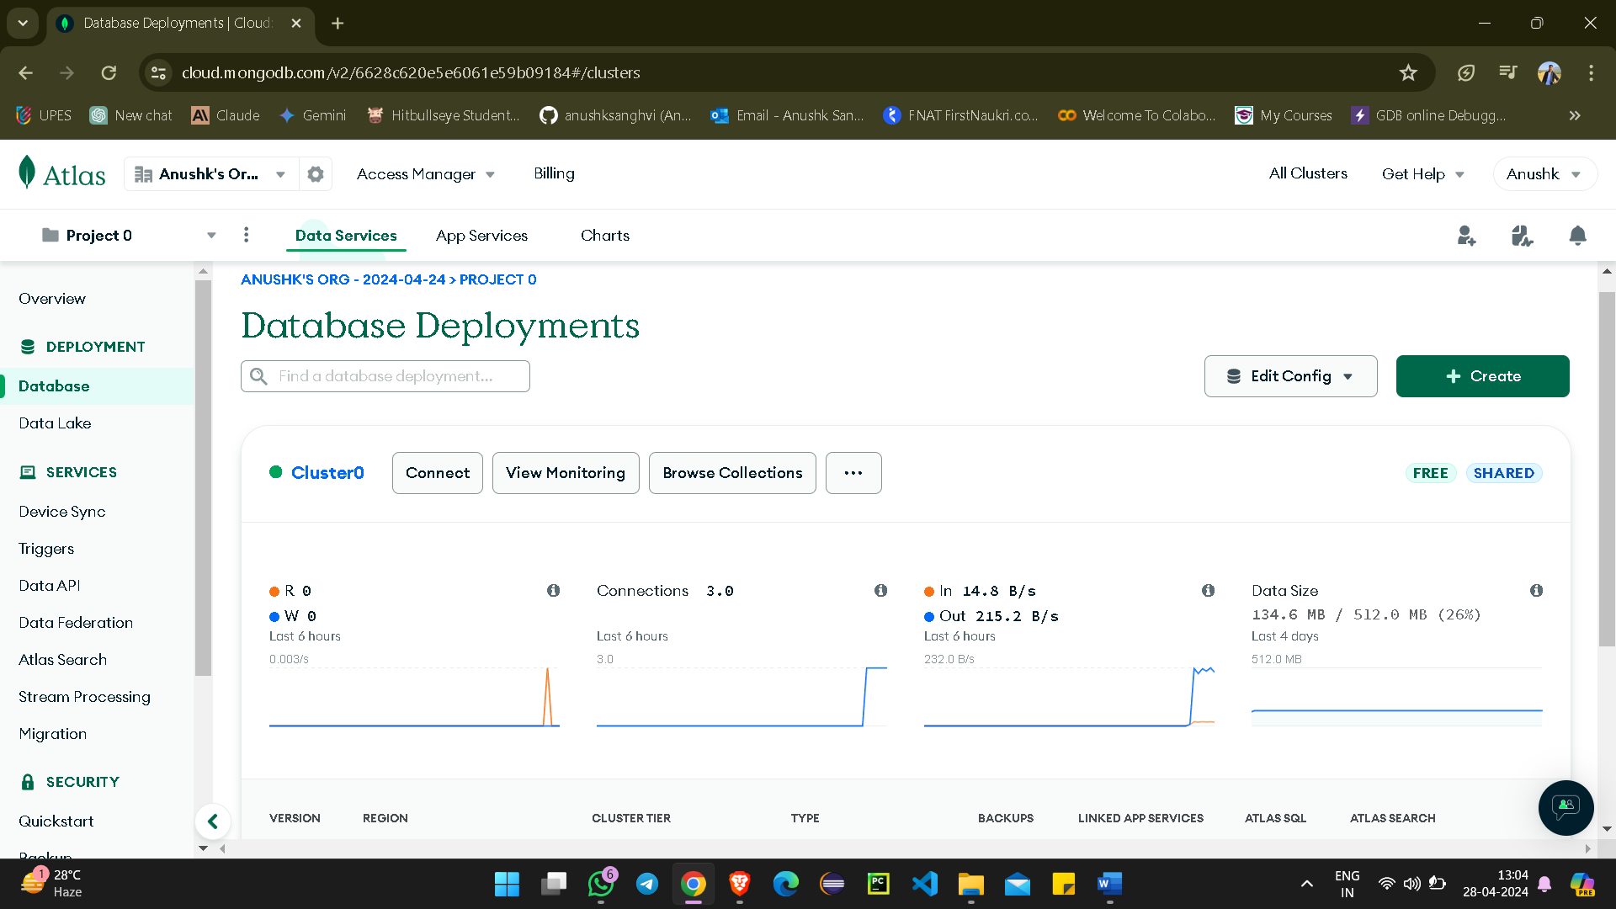

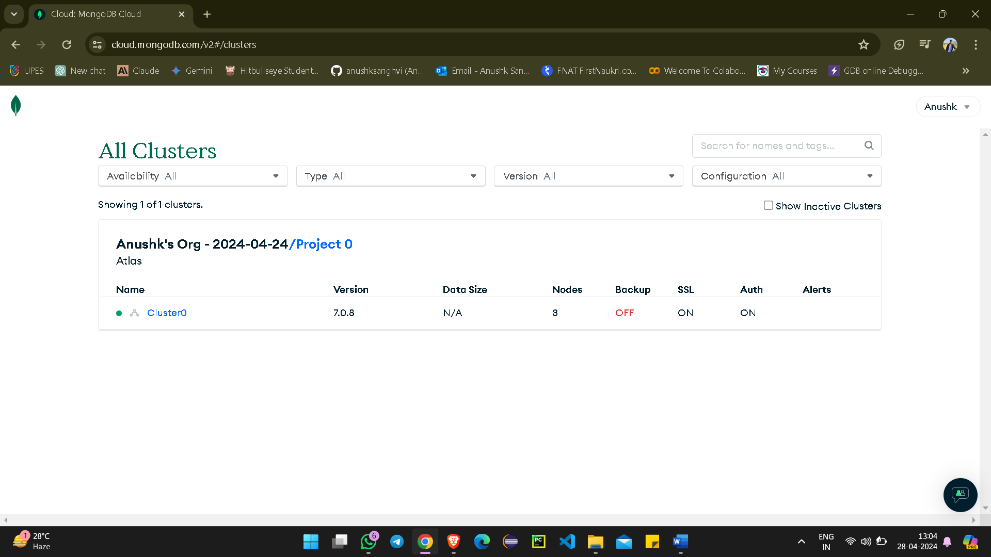

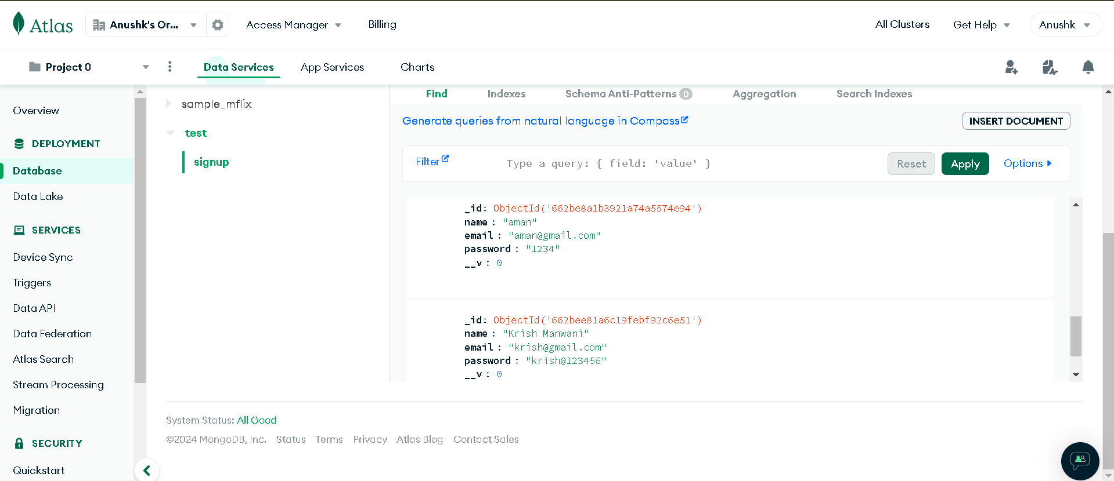

MongoDB store the sign-up user name, email and password that can be used while login.

1. **Backend Development:** 
   * Server-side programming: Utilizing languages like Node.js to handle backend operations.
   * Backend development involves building the server-side logic, APIs, and database integration necessary to support the frontend functionality of the Edu-Scan platform.
2. **Deployment and Hosting:**

Deployment and the hosting of our application is done by using Render.

Render is a cloud platform that provides hosting, scaling, and automation services for web applications and static sites. It offers a simple and intuitive platform for deploying and managing applications, allowing developers to focus on building and improving their products without worrying about infrastructure management.

Deploying and hosting your application with Render offers a seamless experience with robust features for managing your infrastructure. Render simplifies the deployment process by abstracting away much of the complexity associated with traditional hosting solutions.

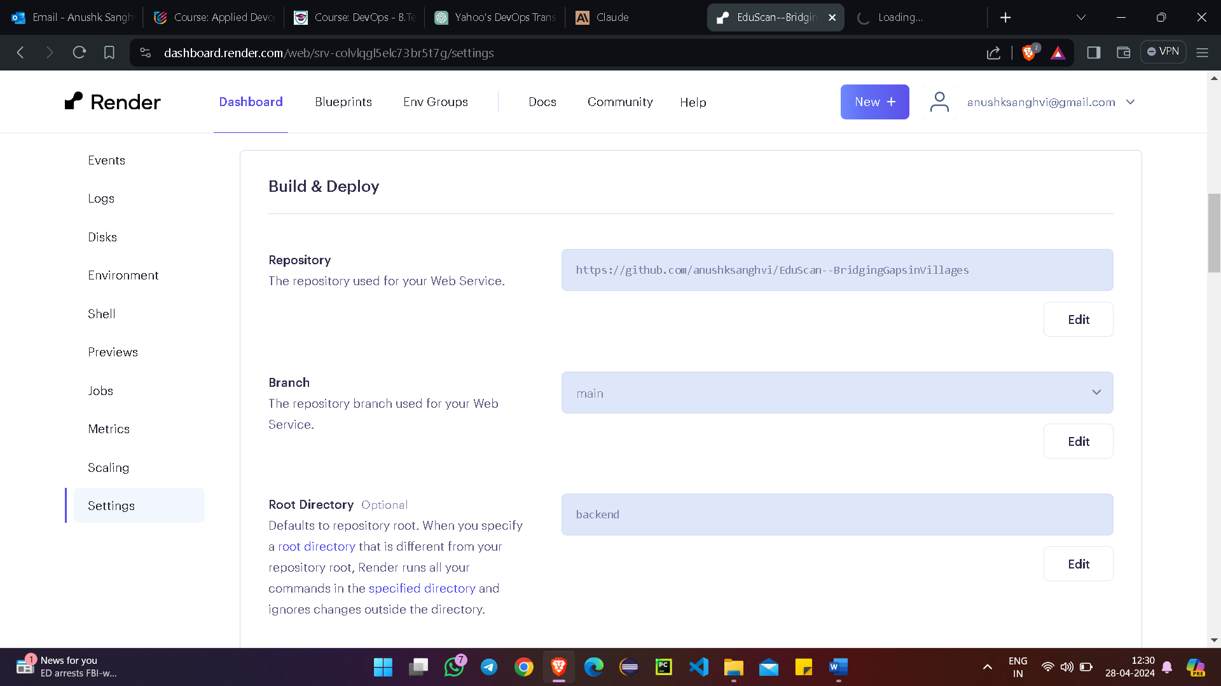

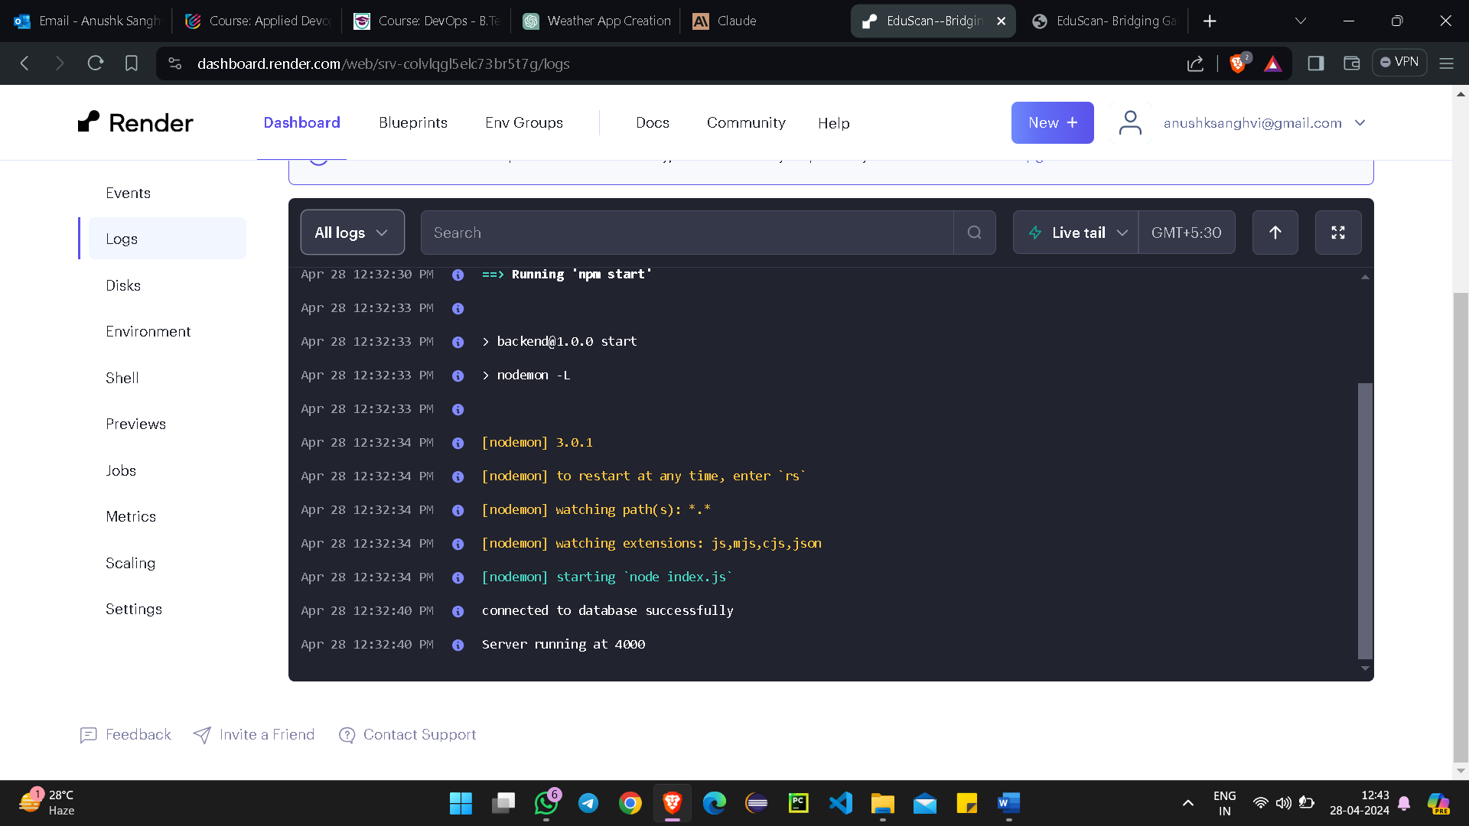

**Project Link:** [**https://github.com/anushksanghvi/EduScan--BridgingGapsinVillages.git**](https://github.com/anushksanghvi/EduScan--BridgingGapsinVillages.git)

## 11. References

1. Abhijit, B., & Rukmini, B. (2018). Digital Study Hall: An Innovative Education Model for Rural India. Journal of Educational Technology, 15(2), 45-58.
2. Bruns, B., Filmer, D., & Patrinos, H. A. (2018). Making Schools Work: New Evidence on Accountability Reforms. The World Bank.
3. Davis, N. E., & Pearce, J. (2019). Scaling up Mobile Learning: Leveraging Community Networks. Journal of Interactive Media in Education, 1(2), 34-47

## 12. Ground Survey

